**METAL TABLE FANS:**

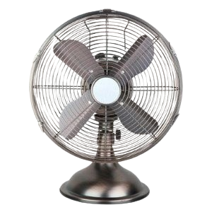

**Price: 8,400.00**

The Metal Table Fan is a sturdy and reliable ventilation solution, designed to provide powerful airflow and cooling relief in a variety of settings. With its durable metal construction, this fan is built to last, offering a robust and stable performance that withstands daily use. Its adjustable speed settings, compact design, and quiet operation make it an ideal choice for offices, homes, and workshops, providing a cool and comfortable environment with minimal distraction.

**Key features of metal table fans include:**

* **Durable Construction** – Made with strong metal frames and blades for long-lasting performance.
* **Adjustable Speed Settings** – Multiple speed options for customizable airflow.
* **Compact & Portable** – Easy to place on tables or desks and move around.
* **Sturdy Build** – Offers stability and durability for consistent operation.
* **Quiet Operation** – Designed for minimal noise during use.
* **Tilt & Height Adjustment** – Adjustable tilt and sometimes height for directional airflow.
* **Energy Efficient** – Low power consumption for cost-effective cooling.